Isuru Viduka Liyanapathirana.
No:-211/2,
Makola North,
Makola.
Mobile:-0716953596
E-mail:- viduka91@gmail.com
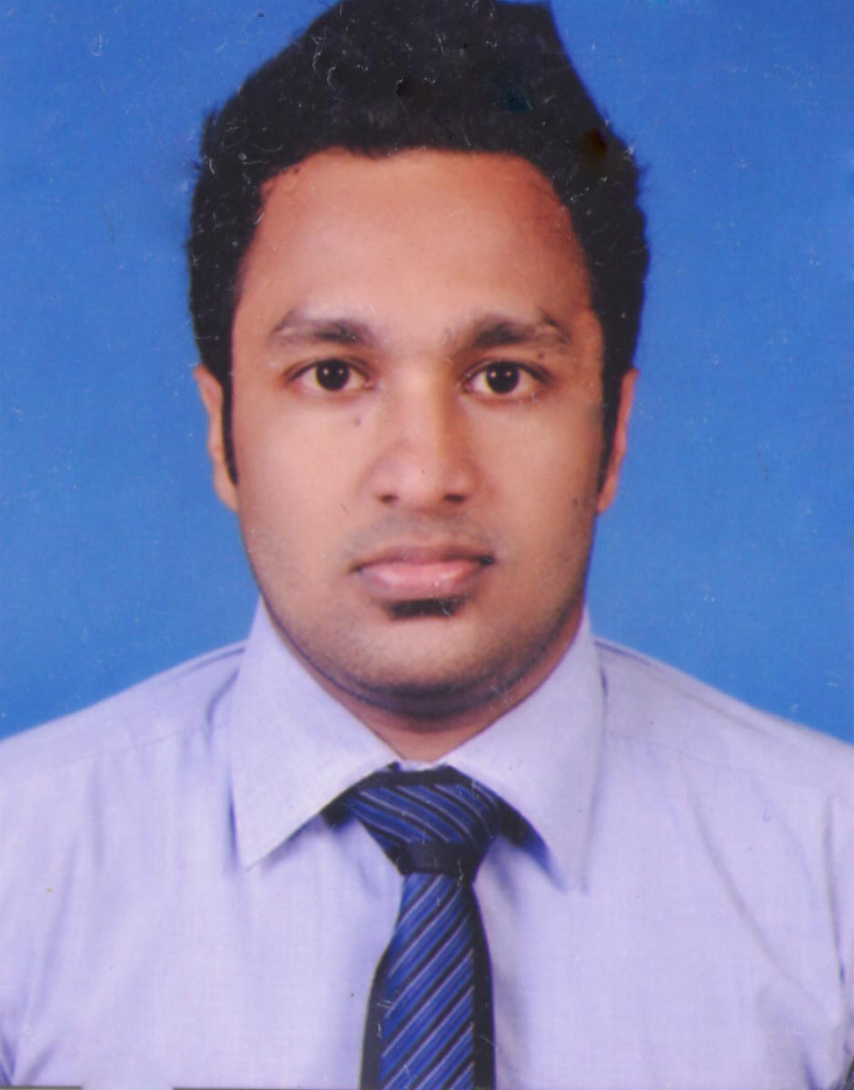

- Address : No. 211/2, Makola, North, Makola.
- Date of Birth : 05.10.1991
- N.I.C Number : 912791238V
- School : Mahanama College
- Civil Status : Single
- Contact Number : 0716953596
- E-Mail : viduka91@gmail.com

CAREER GOAL AND OBJECTIVE

Goal - To be a well rounded individual
Objective - To pursue a career in field, that offers opportunities to utilize my knowledge, skills and experience.

SPECIAL SKILLS AND COMPETENCIES
SPECIAL SKILLS AND COMPETENCIES

- Oral and written communication skills in both Sinhala and English.
- Organizing and Leadership skills.
- Ability of working with a team.
- Ability of hard working.
EMPLOYMENT HISTORY

Customer Care Assistant at LB FINANCE PLC

At present I am working as a Customer Care Assistant at Elakanda branch Since December 2012.

Performing Following duties

- Maintaining day to day Documents.(running Cash book, reserve cash and Petty Cash Book)
- Handling petty Cash and reserve Cash.
- Responding to incoming email
- Producing following reports (Daily payment report, Cash inflows and outflows etc.)

PROFETIONAL QUALIFICATIONS

- I follow CIMA in Wisdom Business Academy.
- I followed Graphic Design course in 3d mind institute (Photoshop, illustrator).
- I have very good knowledge of E-mailing and internet using.
- I followed computer course (Basic Computer Knowledge) in 3d mind.

EDUCATIONAL QUALIFICATIONS

G.C.E. ORDINARY LEVEL EXAMINATION Year - 2007
Index Number -70149917

- Religion A
- Mathematics B
- Science B
- Social Studios B
- Health B
- Sinhala C
- Commerce C
- Art C
- English C

G.C.E. ADVANCE LEVEL EXAMINATION Year - 2011
Index Number -7039085

- Econ A
- Business Studious B
- Accounts S
- English C

EXTRA CURRICULAR ACTIVITIES

- Member of collage Commerce Society
- Committee Member of collage Sinhala Literary Union
- Committee member of collage Buddhist Association
- I’m Junior Prefect of Mahanama College.(2008-2011)
- I’m Junior and Senior Prefect of Dhama Vidyalaya.(2006-2010)

REFREES

Mr. Harald Saman Kumara

Executive,
MAS Active Linea Intimo (PVT) Ltd

Contact No : 0773223451
Mrs. P.A.G.A. Wijesingha,
Teacher of English,

Visiting Lecturer of Aquinas, Borella.

Visiting Lecturer of Open University,

Contact No: 0718328351
Nawala

Ananda Balika vidyalaya,
Colombo 10.

I hear by certify that the above particulars are true and correct to the best of my knowledge.

………………………….. ………………………………………
Date Signature

